ARTIFICIAL INTELLIGENCE (AI)

MODULE 1
- What is AI?
Artificial Intelligence (AI) is a branch of computer science that enables machines and computer systems to think, learn, reason, make decisions, and perform tasks that normally require human intelligence. AI simulates human intelligence in machines, allowing them to learn from data, solve problems, and make decisions.
Examples of AI include ChatGPT, which understands and generates human language; Google Maps, which finds routes and predicts traffic; and self-driving cars, which understand their surroundings and make driving decisions. The main abilities of AI include learning, reasoning, perception, natural language processing, and decision-making.

- Rational agents vs human thinking
Rational Agents | Human Thinking
A rational agent chooses the best possible action to achieve a goal. | Human thinking involves emotions, intuition, experience, and reasoning.
Decisions are based on available information and expected outcomes. | Decisions may be influenced by feelings, beliefs, biases, and personal experiences.
Focuses on what action should be taken. | Focuses on how humans think and understand problems.
Can make decisions quickly using algorithms and data. | Humans may take more time to analyze and make decisions.
Example: A self-driving car chooses the safest route based on traffic and road conditions. | Example: A driver may choose a route based on personal experience or comfort.

- Types of environments
• Fully Observable vs Partially Observable
- Fully Observable: The agent can access all relevant information about the environment.
- Partially Observable: The agent has limited or incomplete information.
- Example: Chess is fully observable; driving is partially observable.
• Deterministic vs Stochastic
- Deterministic: The next state is completely determined by the current state and action.
- Stochastic: The outcome of an action involves uncertainty or randomness.
- Example: Chess is deterministic; weather prediction is stochastic.
• Episodic vs Sequential
- Episodic: Each action is independent of previous actions.
- Sequential: Current actions can affect future situations.
- Example: Image classification is episodic; playing chess is sequential.
• Static vs Dynamic
- Static: The environment does not change while the agent is making a decision.
- Dynamic: The environment can change while the agent is deciding.
- Example: Crossword puzzle is static; driving is dynamic.
• Single-Agent vs Multi-Agent
- Single-Agent: Only one agent operates in the environment.
- Multi-Agent: Multiple agents interact with each other.
- Example: Solving a puzzle is single-agent; football is multi-agent.

- Agent architectures (simple reflex, model-based, goal-based, utility-based, learning agents)

- Simple Reflex Agents:
Simple reflex agents ignore the rest of the percept history and act only on the basis of the current percept. The agent function is based on the condition-action rule. A condition-action rule is a rule that maps a state i.e., a condition to an action. If the
condition is true, then the action is taken, else not. This agent function only succeeds when the environment is fully observable. For simple reflex agents operating in partially observable environments, infinite loops are often unavoidable. It may be possible to escape from infinite loops if the agent can randomize its actions.

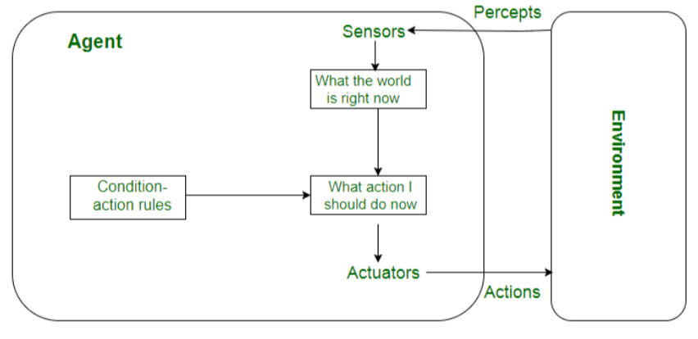
- Model-Based Reflex Agents:
It works by finding a rule whose condition matches the current situation. A model- based agent can handle partially observable environments by the use of a model about the world. The agent has to keep track of the internal state which is adjusted by each percept and that depends on the percept history. The current state is stored inside the agent which maintains some kind of structure describing the part of the world which cannot be seen.
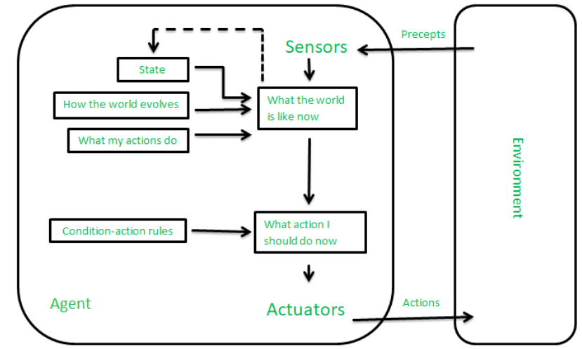

First-Order Logic (FOL)
First-Order Logic (FOL), also called Predicate Logic, is an extension of propositional logic. It is used in AI to represent objects, their properties, and relationships between objects. For example, propositional logic cannot easily represent “Some humans are intelligent”, while FOL can.
1. Basic Elements of FOL:-
Constants: Represent specific objects → John, Mumbai, 1
Variables: Represent objects → x, y, z
Predicates: Represent properties or relationships → Human(x), Likes(x,y)
Functions: Represent relationships that return an object → Father(x)
Connectives: ∧, ∨, ¬, →, ↔
Quantifiers: ∀, ∃
There are two types:
Universal Quantifier (∀): Means “for all” or “every.”
Example: ∀x [Bird(x)→Fly(x)]
Meaning: All birds fly.
Existential Quantifier (∃): Means “there exists” or “some.”
Example: ∃x [Boy(x)∧Intelligent(x)]
Meaning: Some boys are intelligent.
4. Advantages of FOL
Represents objects and relationships.
More expressive than propositional logic.
Can represent statements using “all” and “some.”
Useful for knowledge representation and reasoning in AI.

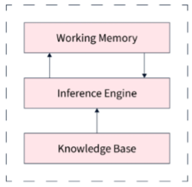
Rule-Based System in AI
A Rule-Based System is an AI system that uses human-defined IF–THEN rules to store, process, and manipulate knowledge to make decisions or solve problems.
Main Components
1. Facts:
Information or statements representing the current state of the system.
2. Rules:
Define what action should be taken based on facts, usually in IF–THEN form.
Example:
IF patient has fever THEN patient may have an infection.
3. Inference Engine / Interpreter:
Matches facts with rules and determines which rule should be applied.
4. Termination Criteria:
Determines when the reasoning process should stop and whether a solution has been reached.
Characteristics
Represents human expert knowledge.
Uses a simple IF–THEN knowledge representation.
Can handle incomplete or uncertain knowledge.
Supports different reasoning and search strategies.
Useful for heuristic and decision-making problems.
Applications
Expert systems
Medical diagnosis
Decision-support systems
Troubleshooting
Chatbots

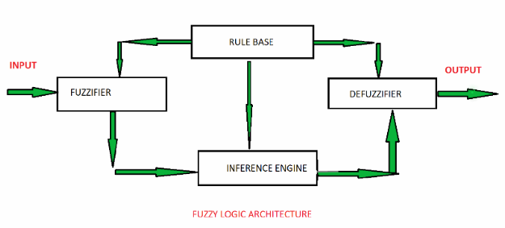
- Fuzzy Logic & Fuzzification
The ’Fuzzy’ word means the things that are not clear or are vague. Sometimes, we cannot decide in real life that the given problem or statement is either true or false. At that time, this concept provides many values between the true and false and gives the flexibility to find the best solution to that problem.
Characteristics of Fuzzy Logic:-
• Flexible: Fuzzy logic is easy to understand, modify, and implement.
• Handles Uncertainty: It is suitable for problems involving approximate, vague, uncertain reasons.
• Degree of Truth: Everything is a matter of degree, with truth values between 0 and 1.
• Non-linear Functions: It can handle functions and systems of arbitrary complexity.
• Easy to Fuzzify: Logical systems can be converted into fuzzy systems.
• Easy Integration: Fuzzy logic can be integrated with programming and control systems.
Architecture of Fuzzy Logic System
1. Rule Base:- Stores a set of IF–THEN rules provided by experts.
Example:
IF temperature is high THEN fan speed is fast.
2. Fuzzification:- Converts crisp input values into fuzzy values using membership functions.
Example:
Temperature = 30°C → Warm = 0.7, Hot = 0.3
3. Inference Engine:- Processes the fuzzy inputs and matches them with the rules in the rule base. It determines which rules should be activated and produces a fuzzy output.
4. Defuzzification:- Converts the fuzzy output into a crisp numerical value that can be used by the system.

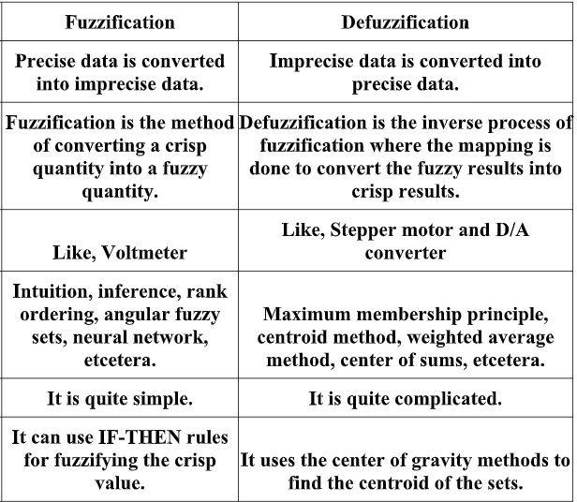

- 4. Bayesian Networks
A Bayesian Network (Bayes Net) is a graphical model that represents probabilistic relationships
among variables using a Directed Acyclic Graph (DAG).
• Nodes represent random variables.
• Directed edges represent dependency relationships.
• Each node has a Conditional Probability Table (CPT).

Example Bayesian Network
Rain

Sprinkler Wet Grass
• Rain influences whether the sprinkler is used.
• Rain and Sprinkler together affect whether the grass becomes wet.

Components
1. Nodes – Random variables.
2. Edges – Dependency relationships.
3. Conditional Probability Tables (CPTs) – Probabilities associated with each node.

Advantages
• Handles uncertain information effectively.
• Represents complex probabilistic relationships.
• Efficient reasoning under uncertainty.
• Supports prediction and diagnosis.

Introduction of Machine Learning
Forms of learning (supervised, unsupervised, reinforcement)
Parametric vs Nonparametric models
Bias–variance tradeoff
Overfitting & regularization
Gradient descent (intuitive)
Classification vs Regression
Artificial Neural Networks: single-layer & concept of deep learning
Ensemble methods & Boosting
Probabilistic & Latent Variable Models: Statistical learning framework
Maximum Likelihood Estimation
Learning with complete data
Hidden variables
EM Algorithm
Hidden Markov Models

